**A PROJECT REPORT ON**

GYM AND NUTRITION

Submitted in partial fulfillments of the requirements for the award

of the Degree of

**BACHELOR OF COMPUTER APPLICATIONS**

**Guru Gobind Singh Indraprastha University, Delhi**



**Under the Guidance of Submitted by**

Mrs. Upasana Singh Sunny Garg(03324002018)

Assistant Professor Avi Mehta(00724002018)

BCA-V Semester

**TRINITY INSTITUTE OF PROFESSIONAL STUDIES**

## (Affiliated to [Guru Gobind Singh Indraprastha University](http://www.ipu.ac.in/), Delhi)

Ranked “A+” Institution by SFRC, Govt. of NCT of India

Recognised under section 2(f) of the UGC Act, 1956

NAAC Accredited “B++” Grade Institution

**CONTENTS**

|  |  |  |
| --- | --- | --- |
| **S.No.** | **Topic** | **Page no.** |
| 1 | Introduction and Objective of the project |  |
| 2 | Tools: Hardware and Software |  |
| 3 | Methodology |  |
| 4 | System design- ER Diagram and DFD |  |
| 5 | Future Scope |  |
| 6 | Conclusion |  |
| 7 | References |  |

**Introduction and Objective**

**INTRODUCTION**

Physical fitness is a general state of health and well-being and, more specifically, the ability to perform aspects of sports, occupations and daily activities. Physical fitness is generally achieved through proper nutrition, moderate-vigorous physical exercise, physical activity, and sufficient rest. Before the industrial revolution, fitness was defined as the capacity to carry out the day’s activities without undue fatigue. However, with automation and changes in lifestyles physical fitness is now considered a measure of the body's ability to function efficiently and effectively in work and leisure activities, to be healthy, to resist hypokinetic diseases, and to meet emergency situations.

Lack of exercise or any physical activity is responsible for 30% mortality in men and 60% of death rate in women. It is the most important cause preventable deaths all over the world. Some of the daily life activities which lead to a sedentary life style are reading, sitting, watching television, use of the computer and playing video games. Diseases whose risk factor increases due to a lack of exercise regime are kidney stones, liver disorders, high blood pressure, diabetes, colon cancer, depression, cardiovascular disease, anxiety, obesity, osteoporosis and clotting of blood. Just like how workouts provide a number of positive benefits to your body.

The health benefits of exercise are considered essential for enhancing [physical activity](https://www.organicfacts.net/health-benefits/other/health-benefits-of-physical-activity.html) and extending your healthy life. Being active and doing regular bodily exercises can prevent major chronic diseases such as [heart](https://www.organicfacts.net/home-remedies/15-best-foods-for-a-healthy-heart.html) problems, [high blood pressure](https://www.organicfacts.net/essential-oils-high-blood-pressure.html), [back pain](https://www.organicfacts.net/home-remedies/home-remedies-for-backache.html), [osteoporosis](https://www.organicfacts.net/osteoporosis.html), joint pains, obesity,improve sex life and even some forms of [cancer](https://www.organicfacts.net/home-remedies/home-remedies-for-cancer.html).

So if you eat your fruits and vegetables, expose yourself to adequate sunlight, get plenty of sleep, and stay well hydrated, your body shouldn't really need a supplemental source of vitamins and minerals, right? Wrong. Here are some powerful reasons that you need to take dietary supplements, no matter how healthy your lifestyle may be.

* Nutrient depletion in the soil. Modern farming techniques utilize fertilizers that actually deplete the soil of essential nutrients. Agriculture relies on the elements in the soil for absorption of proper amounts of minerals, and when this process is interrupted, the plant does not contain essential minerals and cannot form essential vitamins. And if the plant doesn't have it then you're not going to get it from eating the plant!
* Your ability to absorb nutrients from food actually decreases as you age. So while growing children should absolutely be taking a multivitamin to support healthy tissue and bone formation, supplementation becomes equally important for the older population. Sure, you could just eat more food, but this introduces a problem with caloric balance. Beware that many medications also interfere with proper nutrient absorption.
* Exercise increases nutrient needs. Are you an athlete or frequent exerciser? The vast amount of extra oxygen and energy used by active individuals will necessitate nutrient consumption that far exceeds the typical RDA of the average population. Consuming just the stated RDA can actually limit your athletic performance.

**OBJECTIVE**

Through this site, we want to put the lights on this severe problem that is, lack of exercise or improper exercise & nutrition. In this website we will provide the right way of exercise or technique and also we will provide nutrition/supplements.It will be a combination of social welfare and profit generating website. Which provide information about supplements and nutrition like a gym trainer. This is useful for all the person who is dealing with this.

**Proposed System:**

The development of this new system contains the following activities, which try to develop on website by keeping the entire process in the view of database integration approach.

* Secure registration and profile management facilities for Customers.
* Browsing through the e-Mall to see the items that are there in each category of products like Protein, Gainer , Multi-Vitamins , etc.
* Creating a Shopping cart so that customer can Shoppe ‘n’ no. of items and checkout finally with the entire shopping cart
* Payment mechanism for checking out from the Shop( UPI, PAYTM & others )
* Updates to customers about the Recent Items in the Shop.
* Uploading ‘Most Purchased’ Items in each category of products in the Shop like Protein, Gainer , Multi-Vitamins , etc.

**Number of Modules**

The system after careful analysis has been identified to be presented with the following modules:

1. Customer.
2. Admin Module.
3. Shopping Cart
4. Exercises
5. Products

**Tools: Hardware and Software Requirement**

**Hardware requirement**

* 1GB RAM or more
* Processor:Pentium
* Hard disk: 40GB
* Microsoft compatible 101 or more key board
* Keyboard and Mouse

**Software requirements**

* Operating system: Windows 10
* Web technology: php
* Front end: html, css, javascript
* Back end: My Sql
* Web server: apache

**Methodology**

Methodology is a technique or model which require in software development. Its show the steps of working on a website or software.

In this website we will use DevOps Development methodology.

## DevOps deployment methodology

DevOps is not just a development methodology but also a set of practices that supports an organizational culture. DevOps deployment centers on organizational change that enhances collaboration between the departments responsible for different segments of the development life cycle, such as development, quality assurance, and operations.

[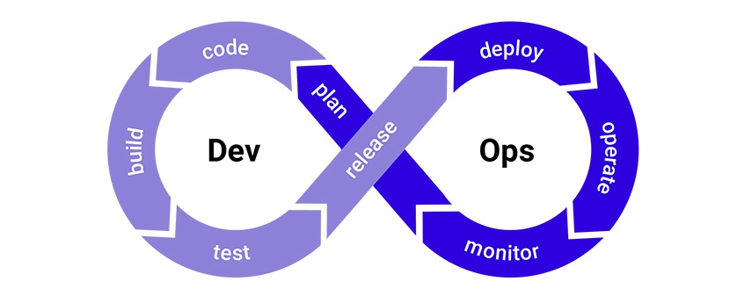](https://www.synopsys.com/blogs/software-security/wp-content/uploads/2017/03/devops-small.jpg)

**ros:** DevOps is focused on improving time to market, lowering the failure rate of new releases, hortening the lead time between fixes, and minimizing disruption while maximizing reliability. To achieve this, DevOps organizations aim to automate [continuous deployment](https://www.synopsys.com/software-integrity/resources/knowledge-database/continuous-deployment.html) to ensure everything happens smoothly and reliably. Companies that use DevOps methods benefit by significantly reducing time to market and improving customer satisfaction, product quality, and employee productivity and efficiency.

**Database Tables**

* Admin
* Product
* Order
* Customer
* Complaint

**System Design: DFD and ER Diagram**

**DFD-0**

SELLER

CUSTOMER

**DFD-1**

**DFD-2**

**E-R DIAGRAM**

**Future scope**

In future we will add some more module like Blog , Diet chart , chatbot , online personal training, motivation series ,GYM Quotes, online order(HEALTHY FOOD) . If any good feedback will be taken positively and if any negative feedback too will be taken positively and try to improve what had lacked. The report is also generated periodically and database will be cleared according to the time span for faster performance.

All functions are secure and user friendly and can be operated by non-technical persons at any time, from any remote location, with an internet connection and web browser .

**Conclusion**

Nowadays, everyone knows the benefits of exercise and a healthy diet but are still unable to maintain it or implement it in there daily life due to lack of proper guidance and knowledge. Hence, our website will provide all the guidance and knowledge one needs to maintain a healthy life. We will provide you with the proper diet plan and exercises according to the individuals body type which will help you in making you life more healthy and Disease free because healthy life is a beautiful life.

**References**

Various sites referred to during making of the project are as follows:

* [www.en.wikipedia.org](http://www.en.wikipedia.org)
* [www.google.com](http://www.google.com)
* https://stackoverflow.com
* https://www.organicfacts.net
* [www.w3cschools.com](http://www.w3cschools.com)

Various books referred to for Java, HTML, XML & DHTML clarification and documentation are as follows:

* J2EE BLACK BOOK.
* Core Java 2, Volume II-Advanced Features by Cay Horetmann Gary Cornelll.
* Head First Servlets and Jsp by by Oreilly.
* Head First HTML with CSS by Chris Schalk(Author), Ed Burns (Author), James Holmes.
* HTML BLACK BOOK.
* Java Handbook by Patrick Naughton.
* Professional Java Programming by Brett Spell.
* Programming with Java by E. Balaguruswamy.
* The Best-Practice Guide to XHTML by Patrick Griffiths.